COMPANY NAME
But this should be your products, not my boyfriend

Group member names
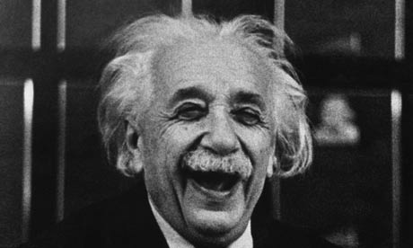
WORKS CITED/
REFERENCES

You can make use of both sides.
Double Take Eye Shadow (PRICE)

Ingredients: (Your mathematically supported list goes here)

And . . . I hope you get the point by now! It should not look exactly like this. Be creative and sell your products but also prove to me that you know the chemistry behind them. Be careful not to plagiarize as you will submit the text to turnitin.com NO LATER THAN TUESDAY, JUNE 5th.

Passionate Kisses Lip Gloss (PRICE)

Ingredients: What you put in ranked by quantity

How it was made: Explain the process. What did you do first, second, third, etc. This is where you can be creative in your descriptions and be sure to draw attention to the good features in the products. Sell it!

Description of the chemistry behind it:
Blah blah blah . . . . why does it have the ingredients it does? What makes them stay mixed or not? Why does it moisturize? Intermolecular forces?

Sweet Escapes Soap (PRICE)

Ingredients: (Your mathematically supported list goes here)

How it was made: Explain the process. What did you do first, second, third, etc. This is where you can be creative in your descriptions and be sure to draw attention to the good features in the products.

Description of the chemistry behind it:
Blah blah blah . . . . what saponification is, how soap works to clean your hands, vocab like emulsifiers, etc. Use in text citations!

